What’s the difference between the NDIS and NDIA?
We are aware these terms are used interchangeably.

The NDIA is the National Disability Insurance Agency.

NDIA is the government agency that implements and manages the National Disability Insurance Scheme (the NDIS) and makes sure people with disability continue to get the support they need.

Who to contact when….

I have a problem with the NDIS
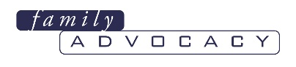 | 1800 620 588  communications@family-advocacy.com
How long do NDIS processes take?
(new plans, plan reviews, changing a plan, plan appeals, or a complaint)
1800 620 588
communications@family-advocacy.com
 | 1800 800 100  https://www.ndis.gov.au/contact/feedback-and-complaints/contact-and-feedback-form
I’m not happy with an NDIS plan or NDIS plan review
1800 620 588
communications@family-advocacy.com

1800 800 100
https://www.ndis.gov.au/participants/how-review-planning-decision

I’m not happy with an NDIA decision of an internal review or appeal
1800 620 588
communications@family-advocacy.com

 | 1800 228 333  https://www.aat.gov.au/apply-for-a-review/national-disability-insurance-scheme-ndis
I’m not happy with an NDIA service or process
1800 800 100
https://www.ndis.gov.au/contact/feedback-and-complaints
I’m not happy with a product or service I bought using an NDIS plan
 | 13 32 20  https://www.fairtrading.nsw.gov.au/news-and-updates/news/tips-for-consumers-purchasing-goods-and-services-through-the-ndis
I’m not happy with the provider of disability supports
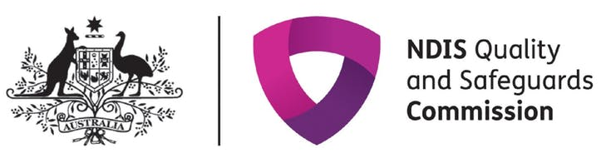 | 1800 035 544  https://www.ndiscommission.gov.au/about/complaints
I’m not happy with the NDIA’s actions
 | 1300 362 072  https://www.ombudsman.gov.au/making-a-complaint/online-complaint-form
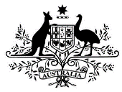 | Contact your Federal MP https://www.aph.gov.au/senators_and_members/members
I’m using NDIS funds to employ support staff and services. Are some NDIS services GST-free?
 | 13 28 65  https://www.ato.gov.au/business/gst/in-detail/your-industry/gst-and-health/?page=6
What are my rights and obligations when I directly employ support staff or a contractor?
 | 131 628  https://www.industrialrelations.nsw.gov.au/employers/
 | 1300 799 675  https://www.fwc.gov.au/
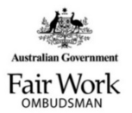 | 13 13 94  https://www.fairwork.gov.au/
What are the tax and superannuation requirements when I directly employ support staff or a contractor?
 | 13 28 66  https://www.ato.gov.au/Individuals/Working/Employee-or-contractor---what-s-the-difference/Employee-or-contractor---tax-and-super-obligations-compared/
How do I pre-plan and understand my NDIS budget?
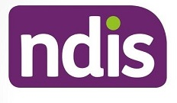 | https://www.supportcalculator.com.au/



Family Advocacy
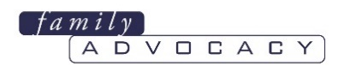
Family Advocacy gives free and confidential service to support people with developmental disability and their families who have concerns about their access to the NDIS or the types of support in their NDIS plan.

Our staff gives phone and email advice on how to:
- prepare for an annual plan review
- how to advocate for your family member
- review an NDIS plan
- how to understand NDIA documentation
- decide whether to appeal an NDIS decision
- troubleshoot


NDIA Participants Service Guarantee
Sets clear timeframes for key NDIS processes to inform participants, families and carers about how long processes will take.

There are timeframes for:
- getting started with the NDIS
- getting a plan
- reviewing or changing a plan,
- making a complaint.
See these timeframes in the Participants Service Guarantee.

NDIA Internal Review
Is an internal review of any decision made by the NDIA. Any person directly affected by an NDIA decision can ask for an internal review. You must ask for this review within three months of getting the NDIA’s notice of the decision. See Family Advocacy’s NDIS Review Guide for help.

NDIA Complaints
The NDIA Complaints Procedure means the NDIA must:
- act immediately where there appears to be a high risk of harm, neglect or abuse
- aim to acknowledge complaints within the next business day from receipt
- call you within two business days of acknowledgement
- aim to resolve complaints within 21 business days of receipt.


Administrative Appeals Tribunal (AAT)
An independent body that can review a range of the decisions made by the NDIA. You cannot ask the AAT to review a decision by the NDIA until the decision has been internally reviewed by the NDIA. Our AAT Guide explains how to apply to the AAT.

NSW Department of Fair Trading
Safeguards the rights of all consumers and advises business and traders on fair and ethical practice. They service individuals and businesses to create a fair, safe and equitable marketplace.

NDIS Quality and Safeguards Commission
An independent agency established to improve the quality and safety of NDIS supports and services.

Commonwealth Ombudsman
Can consider complaints about Australian Government agencies, including the NDIA. They also use information from complaints to help agencies improve their services.

Federal MPs
Support local constituents with issues under the Commonwealth Government.
Australian Tax Office
Responsible for administering the Australian federal taxation system, superannuation legislation, and other associated matters.
Fair Work Commission
The Australian industrial relations tribunal federal independent workplace relations tribunal with the power and authority to regulate and enforce provisions relating to minimum wages and employment conditions, enterprise bargaining, industrial action, dispute resolution, and termination of employment.
Fair Work Ombudsman
An independent statutory agency of the Government of Australia that serves as the central point of contact for free advice and information on the Australian national workplace relations system.
NSW Industrial Relations
Gives information, advice, training and assistance relating to industrial entitle assistance relating to employees’ entitlements and their rights and the employer’s obligations within NSW.

